1. What are the various elements of the Excel interface? Describe how they're used.

Ans: The interface components of Excel include the Quick Access Toolbar, Ribbon, Name Box, Formula Quick Menu, Formula Bar, Status Bar, Worksheet View Options, Zoom Slider Control, and the Zoom Percentage Indicator.

Quick Access Toolbar

The Quick Access Toolbar is found on the top-left of the Excel window which contains the commonly-used commands in Excel. This toolbar can be customized and lets you choose which commands you want to access easily. By default, this contains the save, undo, and redo commands.

Ribbon

The Ribbon interface contains the commands that are available for use in Excel. This has multiple tabs including the File, Home, Insert, Page Layout, Formulas, Data, Review, View, Add-ins, and Help tabs. There are tabs that will appear when necessary; for example, the Format tab appears when you click an inserted shape.

Formula Bar

The Formula Bar is found just beside the Formula Quick Menu. This allows you to enter or edit data, formula or a function that will appear in the selected cell whose name or location appears in the Name Box.

Status Bar

The Status Bar in the bottom-left corner of the Excel window displays various information about the current mode of the workbook.

Worksheet View Options

The Worksheet View Options lets you choose which of the 3 worksheet views you want (Normal, Page Layout, or Page Break Preview). By default, the worksheet view is set to Normal.

Zoom Slider Control

The Zoom Slider Control helps you zoom in and zoom out the worksheet.

1. Write down the various applications of Excel in the industry.

Ans: Data entry.

Data management.

Accounting.

Financial analysis.

Charting and graphing.

Programming.

Time management.

Task management.

1. On the ribbon, make a new tab. Add some different groups, insert commands in the groups and name them according to their commands added. Copy and paste the screenshot of the steps you followed.

Ans:

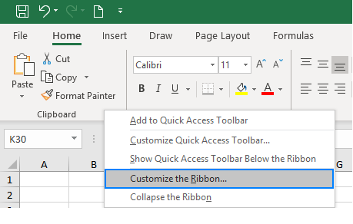

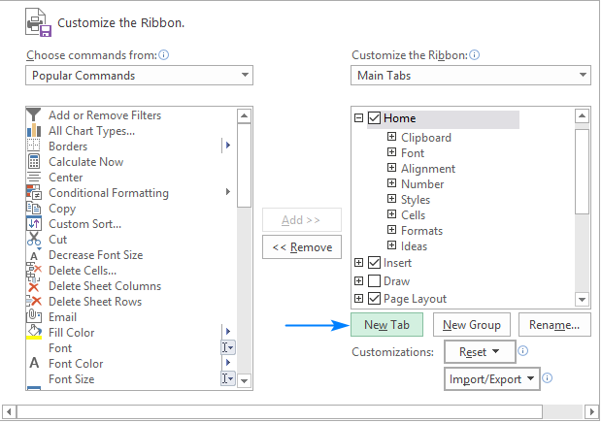

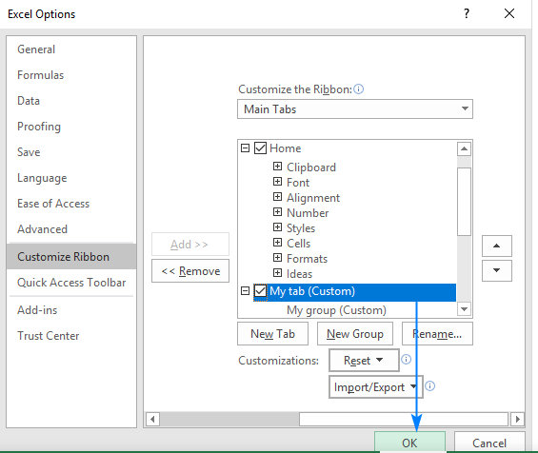

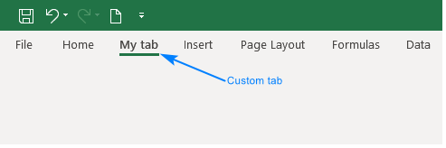

4. Make a list of different shortcut keys that are only connected to formatting with their functions.

Ans: Ctrl + R: Aligns the line or selected text to the right of the screen.

Ctrl + M: Indent the paragraph.

Ctrl + Shift + F: Change the font.

Ctrl + Shift + >: Increase selected font +1pts up to 12pt and then increases font +2pts.

5. What distinguishes Excel from other analytical tools?

Ans:

|  |  |  |
| --- | --- | --- |
| Parameters | Excel | Tableau |
| Definition | It is a spreadsheet application used to organize and format the data. | It is a visualization tool used for detailed analysis. |
| Usage | Suitable for storing data and statistical analysis. | Perfect for the quick and easy representation of data. |
| Security | The inbuilt security features are weak as compared to the tableau. | Several options to secure the data without scripting. |
| User Interface | To unleash the full potential of Excel, knowledge of VBA and basic scripting is required. | We can use tableau with no prior knowledge of coding. |
| Business Purpose | Quick on-off reports. | Best while working with big data. |
| Integration | Excel integrates with around 60 applications. | Tableau integrates with around 250 applications. |

6. Create a table and add a custom header and footer to your table.

